First united Methodist church
310 Oak Street, Irwin, PA 15642
724-863-6858
www.irwinfirstumc.org
irwinfirstumc@comcast.net
Rev. David S. Lake – Pastor
Zaq Phillips – Youth Minister
Dianne Runser – Director of Music Ministry



November 3, 2013
Communion/All Saints’ Sunday/Consecration Sunday

GATHERING & WELCOME

BRINGING IN THE LIGHT

MUSIC OF PREPARATION “For the Saints”

*CALL TO WORSHIP
L: Stand at your watchpost and wait for the Lord.
P: We wait for a vision of truth and hope.
L: Stand at your watchpost and pray to the Lord.
P: We pray for righteousness and understanding.
L: Stand at your watchpost and trust in the Lord.
P: We trust the One who hears our cries and makes justice prevail.
L: Stand at your watchpost and wait for the Lord.

*HYMN OF PRAISE No. 383 “This Is a Day of New Beginnings”

RESPONSIVE READING No. 840 Psalm 119

OPENING PRAYER
God of righteousness, hear our prayer. We come before you with zeal in our hearts, seeking justice for the wronged, hope for the downhearted, and healing for the afflicted. We strain to see your face, and behold the glory of your salvation. Visit us in our need, and transform us in your image, that salvation may come to our house this day, through the power of your Holy Spirit. Amen

MOMENTS OF INFORMALITY
THE MISSION AND MINISTRY OF THE CHURCH
THE WORK OF THE CHURCH

*PASSING THE PEACE OF CHRIST
L: The Peace of Christ be with you.
P: And also with you
L: Please pass the Peace of Christ to your neighbor.

CHILDREN’S MOMENTS

ANTHEM 10:45 – “Come Share the Lord” – Chancel Choir

LITANY FOR ALL SAINTS’ SUNDAY
Leader: Ever living God, this day revives in us memories of loved ones who are no more. What happiness we shared when they walked among us. What joy, when, loving and being loved, we lived our lives together.
People: Their memory is a blessing forever.
Leader: Months or years may have passed, and still we feel near to them. Our hearts yearn for them. Though the bitter grief has softened, a duller pain abides; for the place where once they stood is empty now. The links of life are broken, but the links of love and longing cannot break.
People: Their souls are bound up in ours forever.
Leader: We see them now with the eye of memory, their faults forgiven, their virtues grown larger. So does goodness live, and weakness fade from sight. We remember them with gratitude and bless their names.
People: Their memory is a blessing forever.
Leader: And we remember as well the members who but yesterday were part of our congregation and community. To all who cared for us and labored for all people, we pay tribute. May we prove worthy of carrying on the tradition of our faith, for now the task is ours.
People: Their souls are bound up in ours forever.
Leader: We give You thanks that they now live and reign with You. As a great crowd of witness, they surround us with their blessings, and offer You hymns of praise and thanksgiving.
People: Their souls are alive forevermore. Amen.

Roll Call of Honor

Pastor: The endless cloud of witnesses has gone before us, leaving us a legacy of hope and discipleship. Learn from those who have shown God’s love in all that they have said and done. You have been set on the path of faithful discipleship. Be at peace!

JOYS AND CONCERNS

PASTORAL PRAYER & THE LORD’S PRAYER
Our Father who art in heaven, hallowed be thy name, thy kingdom come, thy will be done on earth as it is in heaven. Give us this day our daily bread; and forgive us our trespasses as we forgive those who trespass against us. And lead us not into temptation, but deliver us from evil, for thine is the kingdom, and the power and the glory forever. AMEN

PRESENTATION OF GOD’S TITHES AND OUR OFFERINGS
(Please save your pledge card to bring forward when you take Communion.)

OFFERTORY “I Have No Hope But Thee”

*DOXOLOGY (tune – “Lord of the Dance”)
“For the gift of creation, for the gift of your love,
And the gift of the Spirit by which we live,
We thank you and give you the fruit of our hands.
May your grace be proclaimed by the gifts that we give.” Amen
*PRAYER OF DEDICATION AND THANKS
God of goodness and joy, you give and give to us. You have held nothing back, not even your precious Son. How it must lift your heart when one of your children releases an explosion of gratitude, as Zacchaeus did when Jesus reached out to him as he made his way into Jericho. Help us to live like that, overflowing in generosity at the realization that, in the midst of our own unworthiness, you claim us as your own and build a bridge of salvation to us. May we be so aware of your redeeming love that our gratitude is too much to contain. In Christ's holy name we pray. Amen.

*HYMN No. 419 “I Am Thine, O Lord”

SERMON SCRIPTURE Luke 19:1-10

SERMON

SACRAMENT OF HOLY COMMUNION II
THE INVITATION
WORDS OF ASSURANCE
SACRAMENT – All are welcome. Please follow the directions of the ushers.
(As you come for Communion, please bring your pledge card forward
and lay it beneath the railing.)
*HYMN OF PARTING No. 389 “Freely, Freely”

BENEDICTION

*MUSIC OF PARTING “For All the Saints”

*Those who are able, please stand.
******************************************************************

******************************************************************
THIS WEEK AT OUR CHURCH

Wednesday, November 6
11:00 Staff Meeting
Office closed until 1:00 PM
6:15 C. Bells
6:30 Fellowship Night
7:00 Yoga
7:15 Choir

Today, Sunday, November 3
Communion
All Saint’s Sunday
Consecration Sunday
8:00 Prayer Time
8:15 Worship
9:30 Sunday School
10:45 Worship
12:00 Soup Luncheon
No Regular FISH & CHIPS meeting
2:30 District Youth at Faith UMC in Delmont
4:15 SonShiners
5:00Temple Bells (all age ringers)
6:00 FISH & CHIPS Halloween Party

Thursday, November 7
5:00 Irwin Ladies Night Out
7:00 Disciple 3

Friday, November 8
9:00 AM Food Bank Truck
Help needed

Saturday, November 9
10:00 AM Food Bank
Help needed

Monday, November 4
7:00 Dartball - Away
Next Sunday, November 10
Baptism Sunday
8:00 Prayer Time
8:15 Worship
9:30 Sunday School
10:45 Worship
2:00 FISH & CHIPS
4:00Temple Bells (all age ringers)
4:45 SonShiners
Tuesday, November 5
Election Day
9:00 Men’s Work Team
6:15 TOPS
7:00 Outreach
7:30 NA

ANNOUNCEMENTS

******************************************************************
CHILDREN’S COLLECTIONS: This week our children’s collection will be sent to the Irwin Volunteer Fire Department to help with their annual fund drive. The money donated will help pay for vehicle costs, equipment, and other operating expenses.
Irwin Volunteer Fire Department - 10/27/2013 $157.35

******************************************************************
Fellowship Night Covered Dish Dinner! On Wednesday, November 6th at 6:30 pm in the Gym, come enjoy a meal and fellowship with our church family & friends. Chicken and beverages will be provided for you. Donations are welcome to help cover the chicken. Please sign up on the clipboard (or call the church office) to bring a side dish or dessert to share. After our meal we'll share some fellowship time just talking. Or, if you'd like to play your favorite game, feel free to bring it along. All are welcome and invited and we hope to see many you there!


******************************************************************
RADA Cutlery Sale…Next Sunday all order forms and money will be due. There are catalogs on a table in the narthex if you need to take one home today and look through it. The vegetable peeler and the paring knife will be available at the bazaar. Look for them at Pastor David’s honey selling table! These make nice teacher gifts or small grab bag items for Christmas. Thanks for supporting our Mission Share 2013 fundraiser!
Questions:
******************************************************************
Christmas Cookie Sale…Coming Soon! During November the Finance Committee will be taking orders for cookie dough that you bake and enjoy! The cookie jar favorites are chocolate chip, oatmeal raisin, candy pieces, triple fudge, white chocolate macadamia, snickerdoodle, white chocolate cranberry and monster (a combo of oatmeal, coconut, candy pieces and peanut butter). They are shipped frozen, and you bake them when you need them! Order forms will be available soon!

******************************************************************

THANKSGIVING FOOD BASKETS: As we enter November, many families will be planning their upcoming holiday meals. Did you have leftovers at your last holiday meal? I know we did and I can’t remember a time when we didn’t have containers full of leftovers. Unfortunately, this is not the case for all families. This year, more than 60 households have made a request for a Thanksgiving basket. Once again the Outreach Committee will be addressing this need in our community. A poster is in the Narthex with a list of everything needed. Please sign up to contribute to the much needed baskets. All donations are due back to the church by Sunday November 24th. If you prefer not to shop but would like to help, please feel free to make a monetary donation and we will do the shopping for you.
******************************************************************
FROM THE FINANCE CHAIR, LAURIE:
Today is Consecration Sunday. In our worship service we will have the opportunity to consecrate our personal commitments for the coming year. During communion you can bring your estimate of giving card to the chancel rail. If you did not receive one in the mail, or you forgot to bring it with you today, additional cards are available on the table in the narthex. We are thankful for your prayers, your presence, your gifts and your service to this church. We have a wonderful church family in Irwin that does so much for the community and in mission and ministry to the world. Together we can make a difference in the lives of many people!

Below is a chart that can help you calculate levels of giving.
Income | 2% | 3% | 4% | 5% | 6% | 7% | 8% | 9% | Tithe
$100 | $ 2 | $ 3 | $ 4 | $ 5 | $ 6 | $ 7 | $ 8 | $ 9 | $ 10
$200 | $ 4 | $ 6 | $ 8 | $ 10 | $ 12 | $ 14 | $ 16 | $ 18 | $ 20
$300 | $ 6 | $ 9 | $ 12 | $ 15 | $ 18 | $ 21 | $ 24 | $ 27 | $ 30
$400 | $ 8 | $ 12 | $ 16 | $ 20 | $ 24 | $ 28 | $ 32 | $ 36 | $ 40
$500 | $ 10 | $ 15 | $ 20 | $ 25 | $ 30 | $ 35 | $ 40 | $ 45 | $ 50
$600 | $ 12 | $ 18 | $ 24 | $ 30 | $ 36 | $ 42 | $ 48 | $ 54 | $ 60
$700 | $ 14 | $ 21 | $ 28 | $ 35 | $ 42 | $ 49 | $ 56 | $ 63 | $ 70
$800 | $ 16 | $ 24 | $ 32 | $ 40 | $ 48 | $ 56 | $ 64 | $ 72 | $ 80
$900 | $ 18 | $ 27 | $ 36 | $ 45 | $ 54 | $ 63 | $ 72 | $ 81 | $ 90
$1,000 | $ 20 | $ 30 | $ 40 | $ 50 | $ 60 | $ 70 | $ 80 | $ 90 | $ 100
$1,500 | $ 30 | $ 45 | $ 60 | $ 75 | $ 90 | $ 105 | $ 120 | $ 135 | $ 150
$2,000 | $ 40 | $ 60 | $ 80 | $ 100 | $ 120 | $ 140 | $ 160 | $ 180 | $ 200
$2,500 | $ 50 | $ 75 | $ 100 | $ 125 | $ 150 | $ 175 | $ 200 | $ 225 | $ 250
$3,000 | $ 60 | $ 90 | $ 120 | $ 150 | $ 180 | $ 210 | $ 240 | $ 270 | $ 300

******************************************************************
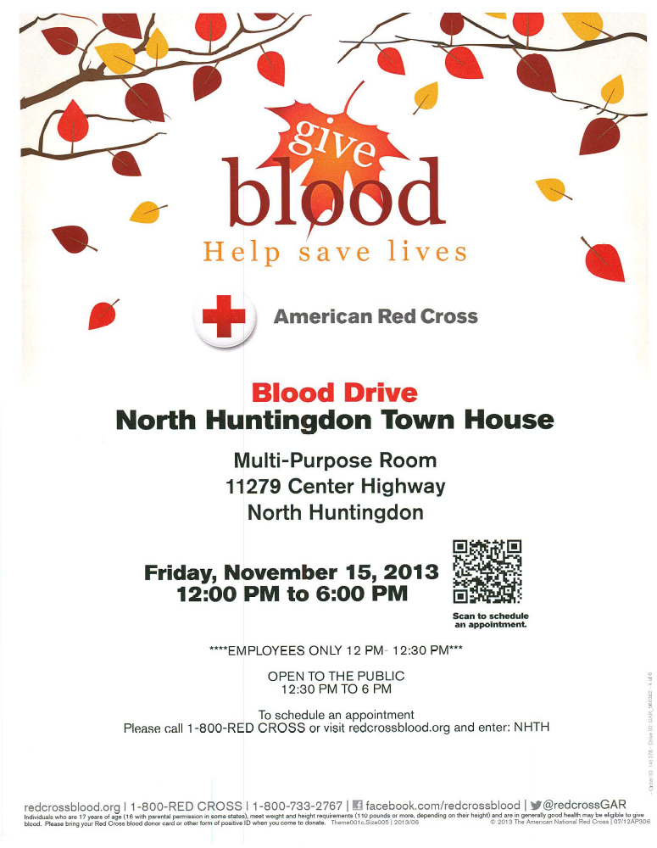
******************************************************************

CHRISTMAS POINSETTIAS: It’s time once again to order the beautiful poinsettias that adorn our church at Christmas! Please see the enclosed order form for complete information. Payment is due with the order and must be turned in by Sunday, November 24th.


******************************************************************
OPERATION REINDEER 2013: It’s that time of the year … time for the 49th annual “Operation Reindeer” gift drive to begin. “Operation Reindeer” is the holiday gift drive for residents of Torrance State Hospital; and the Westmoreland Casemanagement and Support Inc. (WCSI) clients who reside in our communities and receive mental health services through WCSI. The Outreach Committee has chosen to support this gift drive again this year. Our reindeer “Ruby” will be in the narthex beginning November 3rd and will remain there until November 24th to collect your gifts. Please see the November newsletter for the list which provides a guideline in selection your gifts. Extra copies of the list are on the table in the Narthex. All gifts must be NEW, UNBOXED, and UNWRAPPED. The Outreach Committee wishes to thank all of you for your generous support of this project in the past.

******************************************************************

BAZAAR GIFT BASKETS: Remaining gifts baskets from the bazaar are for sale at today's Soup Lunch. All proceeds from baskets sold today will go to the Outreach Committee to support their many missions. Remaining baskets after the Soup Sale will be moved upstairs to the Adult Sunday School room (outside of the Pastor's office). Proceeds from this final sale will support the Rick Simms Mission Work Trip to Phillippi, WV.

******************************************************************

WE ARE LOOKING TO FORM A NEW SUNDAY SCHOOL COMMITTEE. This small group of 3-4 people will be working behind-the-scenes in the Sunday School Department. NO TEACHING WILL BE REQUIRED!!! The goal is to ensure cooperation and communication throughout the entire department, allowing smooth transitions from one level to the next. Responsibilities of the committee members might include maintaining a list of students by grade level, ordering Christmas gifts and 3rd-grade Bibles, promoting Sunday school events and activities, and coordinating efforts between the various grade level departments. All levels, from toddler through adult, will benefit from this centrally-organized committee. Please consider offering your time and talents for this effort, ensuring the ongoing success of Christian education in our church! If interested, please contact the church office.

******************************************************************

NURSERY NEWS: We would like to remind all volunteers in the Nursery that you must have UP TO DATE clearances. Due to Safe Sanctuaries regulations, if your clearances are not up to date and on file in the church office, you will not be able to help out. This could put a strain on the Nursery since there are several children and parents who benefit from our work. It is getting difficult to get people involved and it could harm a successful program of the church. Application forms are available in the church office and the church will pay the fees.

In addition we are always looking for volunteers to help out with the Nursery.
******************************************************************


